120″ Telescope Cassegrain Focus

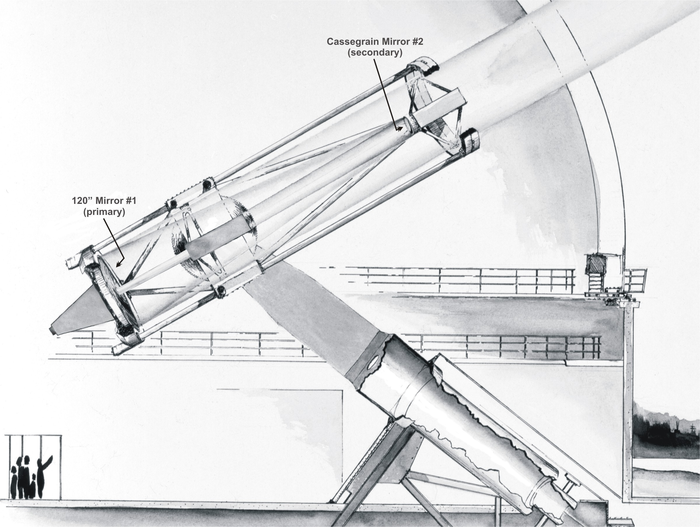

Optic # | Optic Notes | Procedures
#1 | Bare aluminum  Subjected to oil drips and occasional moisture  Up facing mirror – Protective cover | Inspect monthly  Co₂ monthly  Wash annually
#2 | Bare aluminum  Down facing mirror | Inspect monthly  Wash as needed

